
Yenepoya Institute of Arts, Science, Commerce and Management

Final Project Report
On

IDENTITY SECURITY FRAMEWORK OF MANUFACTURING

Student Name: Angelica Alex

Industry Mentor: | Vikyath Shetty | Guided by: | Shashank

Table of Contents
- Background
  - Aim
  - Technologies
  - Hardware Architecture
  - Software Architecture
- System
  - Requirements
    - Functional requirements
    - User requirements
    - Environmental requirements
  - Design and Architecture
  - Implementation
  - Testing
  - Graphical User Interface (GUI) Layout
  - Customer testing
  - Evaluation

- Snapshots of the Project
- Conclusions
- Further development or research
- References
- Appendix

1. Executive Summary
The Identity Security Framework for Manufacturing System is a web-based application designed to ensure secure and efficient management of inventory and production processes within a manufacturing environment. The system is developed using the Flask framework and SQLite database, providing a lightweight yet effective solution suitable for small to medium-scale manufacturing setups.
The primary goal of this project is to implement a secure identity-based system that controls user access, tracks production activities, and maintains accurate inventory records. The system introduces role-based access control with three distinct user roles: staff, manager, and admin. Each role has clearly defined permissions to ensure that sensitive operations are restricted and monitored.
Staff users are responsible for updating inventory levels and recording production activities. Managers are provided with monitoring capabilities to oversee system operations, while administrators have full control over user management, inventory control, and system logs. This structured role distribution enhances accountability and prevents unauthorized access.
A key feature of this system is the implementation of secure authentication mechanisms. User credentials are protected using password hashing through the Werkzeug library. Session-based authentication is used to maintain user login states securely across different pages of the application.
The system also emphasizes audit logging, which plays a critical role in tracking user activities. Every significant action, such as inventory updates or production entries, is recorded in a log system along with timestamps and user identification. This ensures transparency, traceability, and accountability within the manufacturing workflow.
Additionally, the inventory management module allows real-time updates of stock levels, reducing errors and improving operational efficiency. The production tracking module records manufactured quantities and associates them with specific users, enabling better monitoring of production performance.
Overall, this project demonstrates how a secure identity framework can be integrated into a manufacturing system to improve data integrity, enforce access control, and provide a reliable audit trail. The application is designed to be simple, scalable, and user-friendly, making it suitable for practical implementation in real-world scenarios.

2. Background
Manufacturing systems involve the management of materials, production processes, and workforce activities to produce goods efficiently. In such environments, maintaining accurate records of inventory and production is essential. Any error in tracking stock or production can lead to delays, resource wastage, and operational inefficiencies.
Traditional systems often lack proper security and structured access control. Multiple users may access the same system without restrictions, leading to risks such as unauthorized data modification and lack of accountability. To overcome these issues, a secure identity-based framework is required.
Modern web technologies like Flask and SQLite enable the development of lightweight and efficient systems. Security mechanisms such as password hashing using Werkzeug help protect user credentials and ensure safe authentication.
This project focuses on building a secure manufacturing system that integrates identity security, inventory management, production tracking, and audit logging into a single platform.
2.1 Aim
The main aim of this project is to develop a secure web-based system for managing inventory and production in a manufacturing environment.
The system is designed to:
- Provide secure user authentication and session management
- Implement role-based access control (staff, manager, admin)
- Enable accurate inventory updates
- Record production activities efficiently
- Maintain audit logs to track all user actions
The goal is to improve data security, accountability, and operational efficiency.
2.2 Technologies
The system is developed using the following technologies:
- Backend Framework: Flask
Used to handle server-side logic and routing

- Database: SQLite
Stores user data, inventory, production records, and logs
- Frontend: HTML and Tailwind CSS
Provides a clean and responsive user interface
- Security Library: Werkzeug
Used for password hashing and secure authentication
These technologies are chosen for their simplicity, efficiency, and ease of deployment.
2.3 Hardware Architecture
The system follows a client-server architecture.
- Client Side:
Users access the system through a web browser on a computer or laptop
- Server Side:
The Flask application runs on a server that processes requests
- Database:
SQLite database stores all system data locally on the server
This architecture ensures centralized data management and secure access.
2.4 Software Architecture
The system follows a three-layer structure:
- Frontend Layer:
Handles user interface using HTML and Tailwind CSS
- Application Layer:
Managed by the Flask framework, processes user requests, applies logic, and enforces access control
- Database Layer:
SQLite database stores and retrieves data related to users, inventory, production, and logs
Flow of operation:
User → Browser Interface → Flask Backend → Database → Response to User.
This architecture ensures proper separation of concerns, making the system easier to maintain and extend.

3. System
The system is designed as a secure web-based application for managing manufacturing operations such as inventory updates, production tracking, and user activity monitoring. It ensures that only authorized users can access specific functionalities through role-based access control. The system is developed using Flask with SQLite as the backend database.
The main components of the system include user authentication, inventory management, production tracking, and audit logging. Each component works together to maintain data accuracy, security, and accountability.
3.1 Requirements
3.1.1 Functional Requirements
The functional requirements define what the system should do.
- The system must allow users to register and log in securely
- The system must hash passwords using Werkzeug
- The system must support session-based authentication
- The system must implement role-based access control (staff, manager, admin)
Inventory Management:
- Staff users must be able to update inventory quantities
- Admin users must be able to add or remove inventory items
- The system must display current stock levels
Production Tracking:
- Staff users must record produced items
- Each production record must be linked to a user
- The system must store production history
Audit Logging (VERY IMPORTANT):
- Every user action must be logged
- Logs must include user ID, action performed, and timestamp
- Admin users must be able to view logs

3.1.2 User Requirements
The system should be easy to use for all types of users.
- Simple login and navigation interface
- Clear display of inventory and production data
- Easy-to-use forms for updating stock and recording production
- Separate dashboards based on user roles
- Quick access to logs for monitoring
3.1.3 Environmental Requirements
- The system must run on any modern web browser
- Requires Python environment to run the Flask server
- No high-end hardware is required
- Works on local system or small server setup
3.2 Design and Architecture
Application Design
The application is designed as a modular system where each feature is handled separately:
- Authentication module
- Inventory module
- Production module
- Logging module
Each module interacts with the database and follows secure access rules.
Process Flow
- User logs into the system
- System verifies credentials
- User is redirected based on role
- Staff updates inventory or records production

- System stores data in database
- System logs the action
- Manager/Admin monitors activities
Information Flow
User Input → Flask Backend → Database → Response → Display to User
All actions are processed through the backend to ensure security and validation.
Components Design
- Staff:
Updates inventory and records production
- Manager:
Monitors system activity and production
- Admin:
Manages users, inventory, and logs
Each component has restricted access to maintain system security.
3.3 Implementation
The system is implemented using the Flask framework with structured routing.
Flask Routes
- /register – User registration
- /login – User login
- /dashboard – Role-based dashboard
- /inventory – View and update stock
- /production – Record production
- /logs – View audit logs

Database Operations
The system uses SQLite with the following tables:

- users
- inventory
- production
- logs
Operations include:
- Insert (add users, logs, production data)
- Update (inventory changes)
- Select (display data)
Logging System (IMPORTANT)
Every action is recorded in the logs table:
- Login activity
- Inventory updates
- Production entries
This ensures full traceability of user actions.
3.4 Testing
Testing ensures that the system works correctly.
Stock Update Testing
- Verify inventory updates correctly
- Check for invalid inputs
- Ensure only authorized users can update
Production Logging Testing
- Verify production entries are stored
- Ensure correct user mapping
- Check log generation for each action
3.5 Graphical User Interface (GUI) Layout
The system provides a clean and simple interface.

- Login and registration pages
- Inventory dashboard showing stock levels
- Production entry form
- Admin panel for managing users and logs
The interface is designed using HTML and Tailwind CSS for responsiveness.
3.6 Customer Testing
The system is tested by users to evaluate usability.
- Users can easily navigate between pages
- Forms are simple and understandable
- System provides quick feedback after actions
Feedback confirms that the system is user-friendly and efficient.
3.7 Evaluation
The system is evaluated based on performance and correctness.
- Performance:
Fast response due to lightweight framework
- Accuracy:
Inventory and production data are stored correctly
- Security:
Password hashing and role-based access ensure protection
- Audit Logging:
Provides complete tracking of all user actions

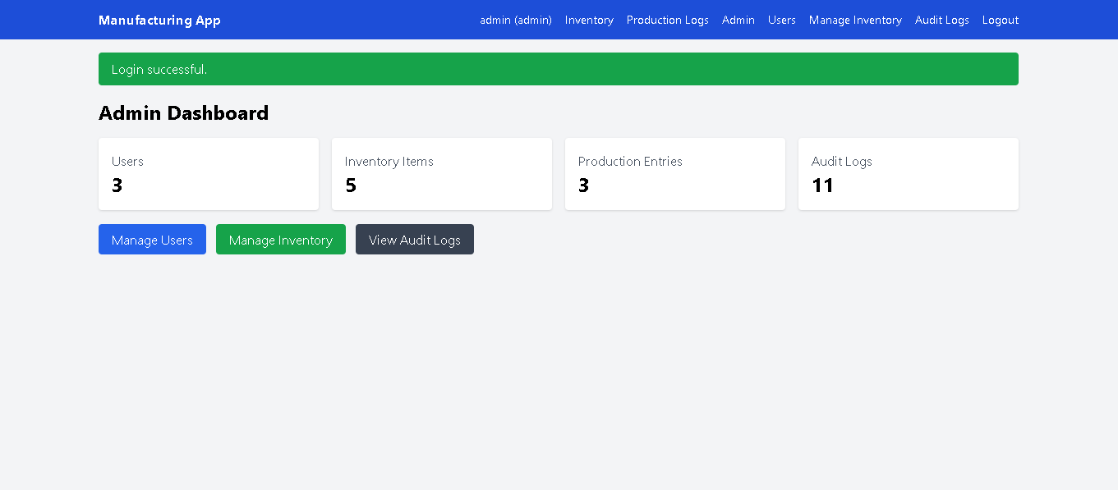
4. Snapshots of the Project

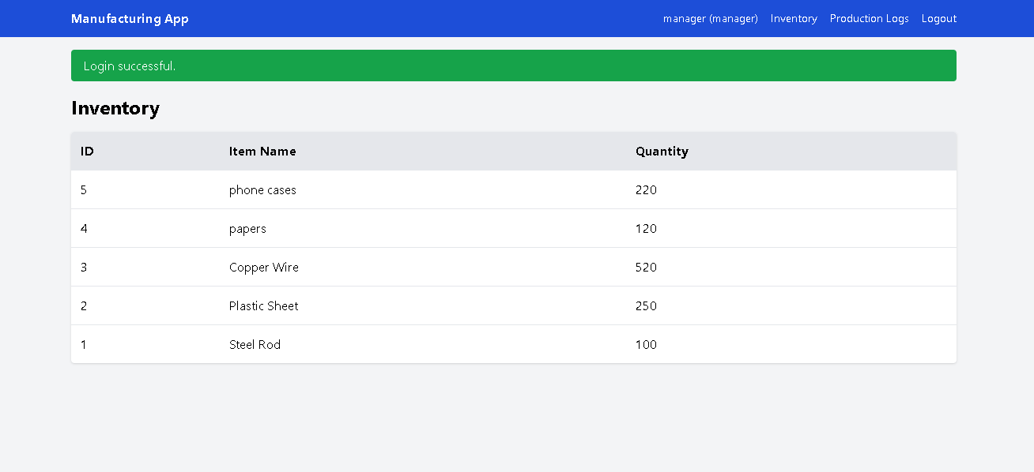

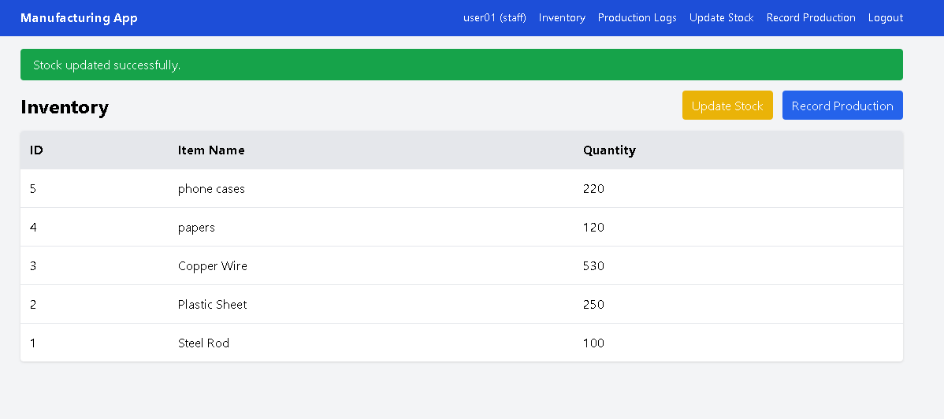

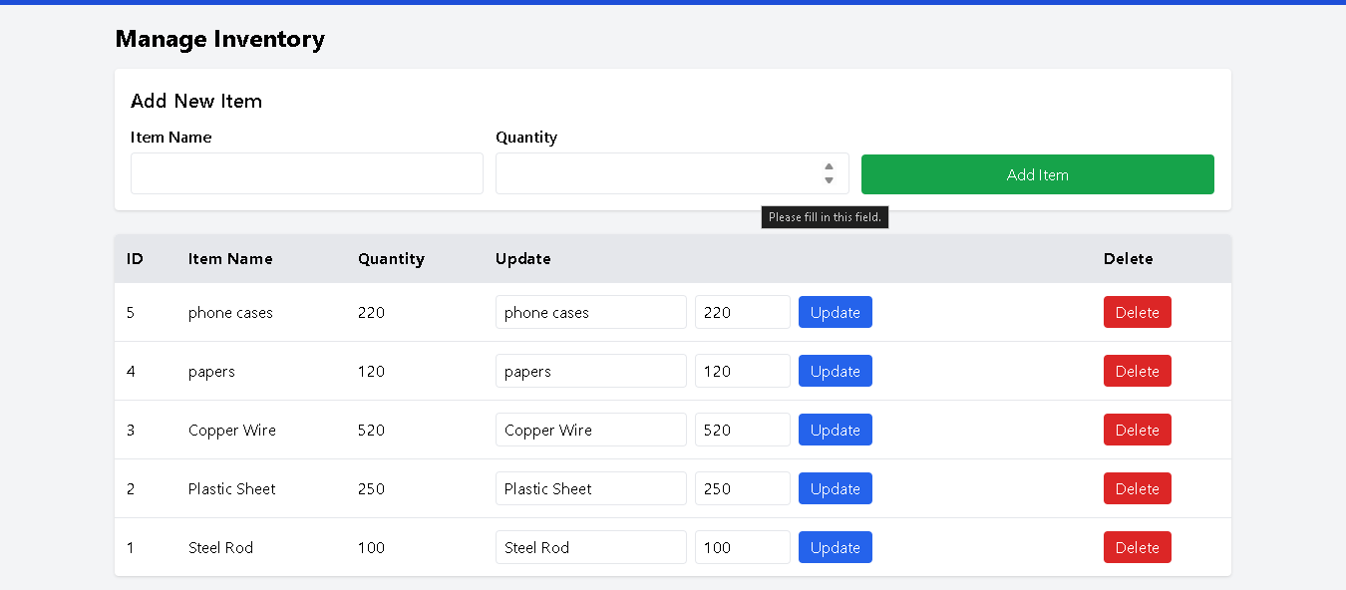

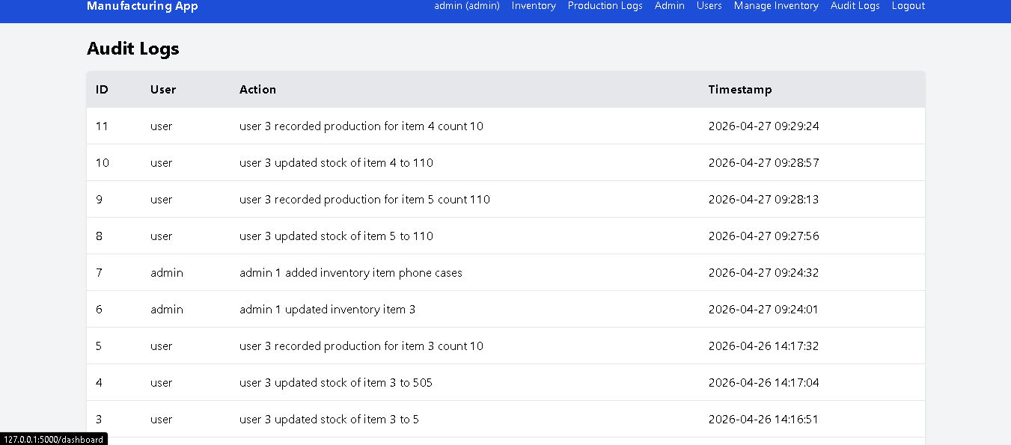

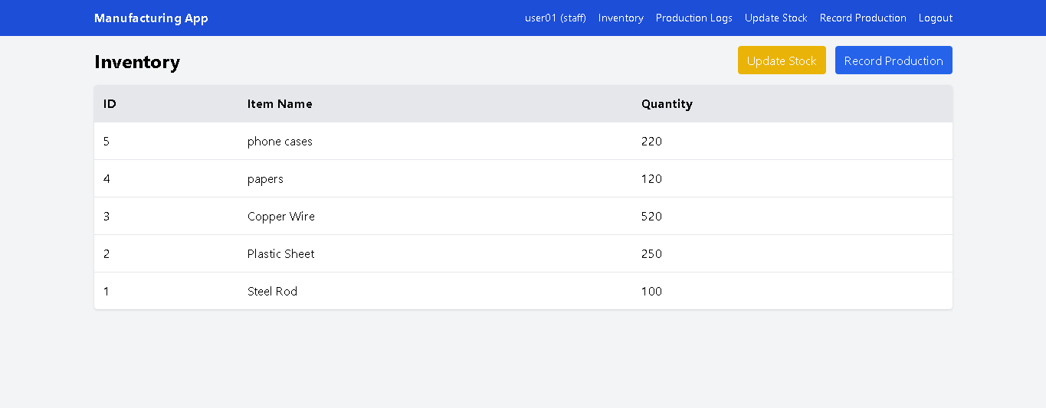

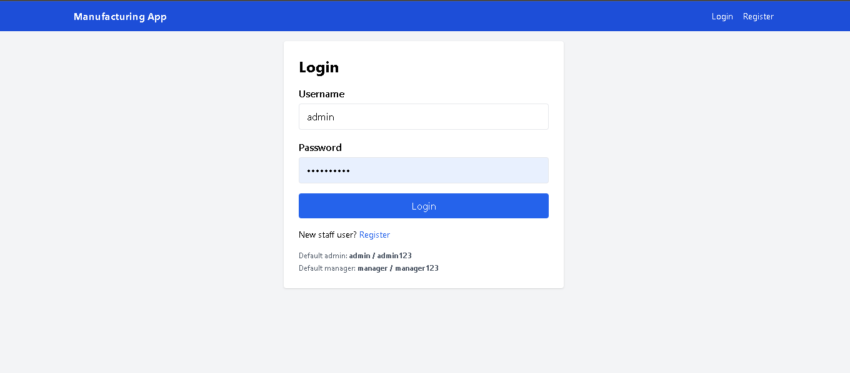
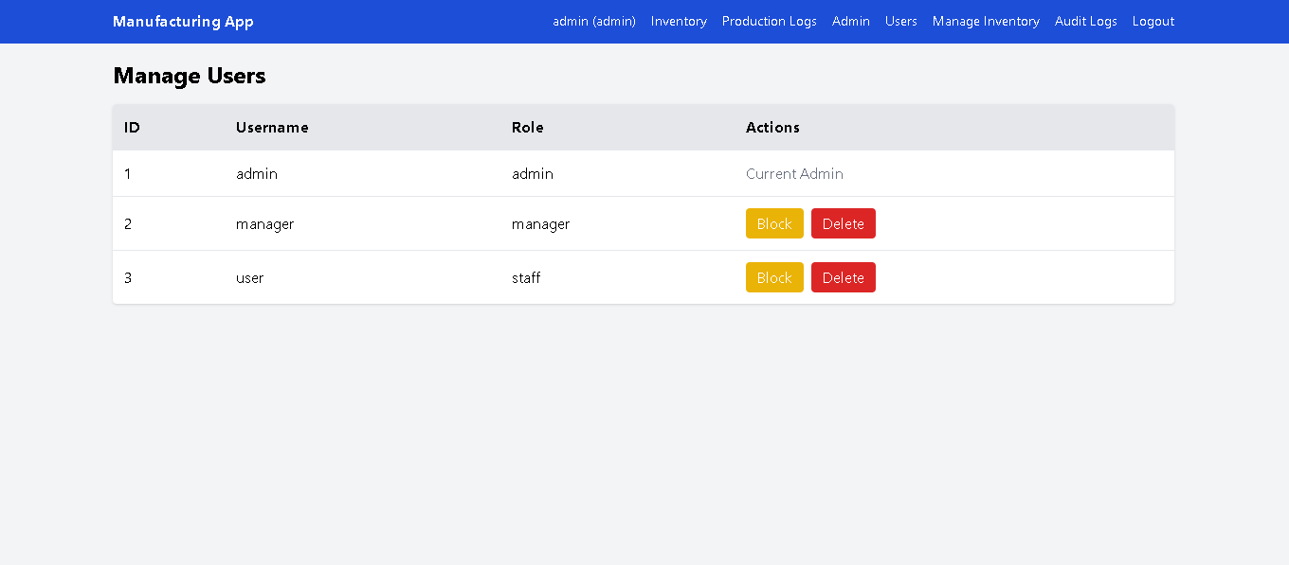

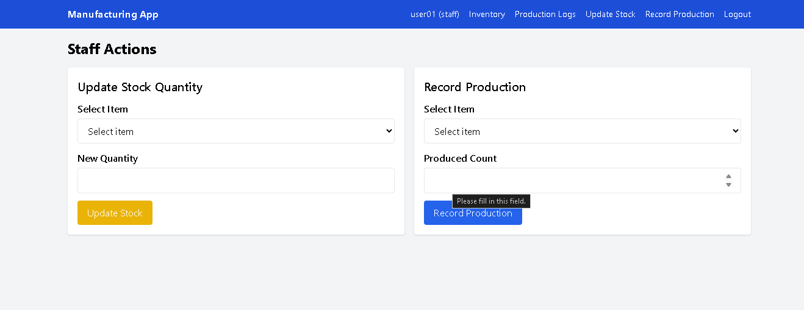

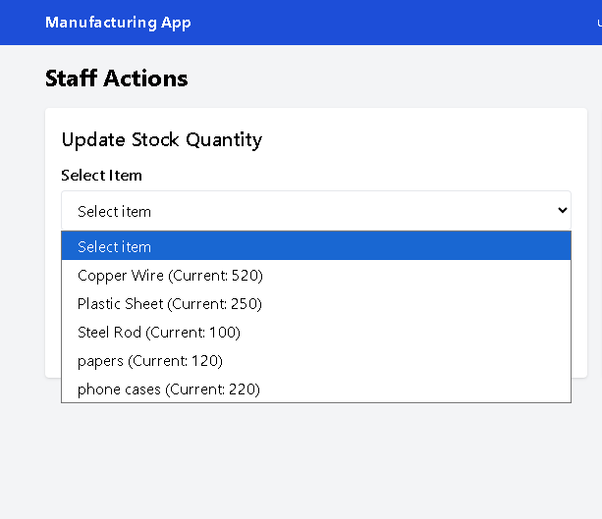

5. Conclusions
The Identity Security Framework for Manufacturing System successfully demonstrates how a secure and structured web application can be used to manage manufacturing operations efficiently. The system integrates identity-based access control with core functionalities such as inventory management, production tracking, and audit logging, ensuring both operational efficiency and data security.
One of the key achievements of this project is the implementation of secure user authentication using the Flask framework along with password hashing provided by Werkzeug. This ensures that user credentials are protected and unauthorized access is prevented. The use of session-based authentication further enhances security by maintaining controlled user sessions throughout system interaction.
The role-based access control mechanism plays an important role in defining system responsibilities. Staff users are limited to updating inventory and recording production, managers are responsible for monitoring activities, and administrators have full control over user management, inventory, and logs. This separation of roles reduces the risk of misuse and improves accountability within the system.
The inventory management module ensures accurate and real-time tracking of stock levels. This helps in avoiding issues such as overstocking or shortages, which are common in traditional systems. The production tracking feature allows the system to maintain detailed records of manufactured items along with user information, making it easier to monitor productivity and identify discrepancies.
A major strength of the system is the audit logging functionality. Every important action performed by users is recorded with a timestamp and user identification. This provides complete transparency and traceability, which is essential in a manufacturing environment. Audit logs help in detecting errors, analyzing system usage, and ensuring that all operations follow defined rules.
The use of SQLite makes the system lightweight and easy to deploy, while still providing reliable data storage. The overall system design follows a clear and modular architecture, making it easy to maintain and extend in the future.
In conclusion, the project meets all its objectives by providing a secure, efficient, and user-friendly solution for managing manufacturing processes. It highlights the importance of identity security, structured access control, and activity tracking in modern systems. The developed application can serve as a strong foundation for further enhancements and real-world implementation in manufacturing environments.

6. Further Development or Research
The current system provides a secure and efficient solution for managing inventory, production tracking, and user activity in a manufacturing environment. However, there are several areas where the system can be enhanced to improve its functionality, scalability, and real-world applicability.
One possible improvement is the implementation of more advanced authentication mechanisms. Currently, the system uses session-based authentication with password hashing through Werkzeug. In the future, additional security layers such as multi-factor authentication (MFA) can be introduced to further strengthen user verification and reduce the risk of unauthorized access.
Another area of enhancement is improving the inventory management system. Features such as low-stock alerts, automatic notifications, and detailed inventory reports can be added. These features will help users make better decisions and ensure that production processes are not affected due to insufficient materials.
The production tracking module can also be extended by adding detailed analytics. For example, the system can generate daily, weekly, or monthly production reports to help managers evaluate performance and identify trends. This would provide better insights into operational efficiency.
The audit logging system, which is a key component of this project, can be further enhanced by implementing advanced log analysis features. Logs can be filtered, searched, and categorized based on user actions or time periods. Additionally, exporting logs for external analysis can be included to support auditing and compliance requirements.
From a technical perspective, the system can be scaled by replacing SQLite with more robust database systems such as MySQL or PostgreSQL for handling larger datasets and multiple concurrent users. Similarly, deploying the Flask application on a cloud server can improve accessibility and availability.
The user interface can also be improved by adding more interactive dashboards and visual representations of data. This would make it easier for managers and administrators to understand system activities and make informed decisions.
In terms of research, further studies can focus on improving identity security models in manufacturing systems, especially in distributed environments. Exploring better access control mechanisms and secure logging practices can contribute to building more reliable and secure systems.

7. References
[1] Flask Documentation, “Flask Web Framework,” Available: https://flask.palletsprojects.com/
[2] SQLite Documentation, “SQLite Database Engine,” Available: https://www.sqlite.org/docs.html
[3] Werkzeug Documentation, “Security Helpers (Password Hashing),” Available: https://werkzeug.palletsprojects.com/
[4] Mozilla Developer Network (MDN), “HTML: HyperText Markup Language,” Available: https://developer.mozilla.org/en-US/docs/Web/HTML
[5] Tailwind CSS Documentation, “Utility-First CSS Framework,” Available: https://tailwindcss.com/docs
[6] Python Software Foundation, “Python Official Documentation,” Available: https://docs.python.org/3/
[7] OWASP Foundation, “Authentication and Session Management,” Available: https://owasp.org/www-project-top-ten/
[8] GeeksforGeeks, “Flask Login System Tutorial,” Available: https://www.geeksforgeeks.org/flask-login-system/
[9] TutorialsPoint, “SQLite Tutorial,” Available: https://www.tutorialspoint.com/sqlite/index.htm
[10] IBM, “What is Inventory Management?,” Available: https://www.ibm.com/topics/inventory-management
[11] Microsoft, “Web Application Architecture Guide,” Available: https://learn.microsoft.com/en-us/azure/architecture/

8. Appendix
The appendix section provides additional technical details about the system, including database structure, modules, and important components used in the implementation. This section helps in understanding how the system is organized internally.
8.1 Database Schema
The system uses the SQLite to store all application data. The database consists of four main tables:
1. Users Table
Stores user credentials and roles.
- id – Unique identifier for each user
- username – User login name
- password – Hashed password
- role – Defines user type (staff, manager, admin)
2. Inventory Table
Stores information about available items and stock levels.
- id – Unique identifier for each item
- item_name – Name of the item
- quantity – Available stock
3. Production Table
Stores production records.
- id – Unique identifier
- item_id – References inventory item
- produced_count – Quantity produced
- user_id – References the user who recorded production

4. Logs Table (Audit Logging )
Tracks all user activities in the system.
- id – Unique identifier
- user_id – References the user
- action – Description of the activity
- timestamp – Date and time of action
This table ensures accountability and traceability of all operations.
8.2 Modules Description
The system is divided into several modules for better organization:
1. Authentication Module
- Handles user registration and login
- Uses password hashing with Werkzeug
- Maintains session-based authentication
2. Inventory Module
- Allows staff to update stock
- Allows admin to manage inventory
- Displays current stock levels
3. Production Module
- Records production data
- Links production to users
- Maintains production history
4. Logging Module (Critical Component)
- Records all user actions
- Stores logs with timestamps
- Enables admin to monitor system usage

8.3 Key Functional Flow
- User registers and logs into the system
- System verifies credentials securely
- User is assigned access based on role
- Staff updates inventory or records production
- System updates the database
- Action is recorded in logs
- Admin/Manager monitors system activities
8.4 Security Mechanisms
The system implements several security features:
- Password hashing using Werkzeug
- Session-based authentication
- Role-based access control
- Audit logging for all actions
These measures ensure that the system remains secure and reliable.
8.5 Sample Data Flow Example
- A staff user logs in
- Updates inventory quantity for an item
- Records production count
- The system saves data in inventory and production tables
- A log entry is created with user ID and timestamp
This demonstrates how all components of the system work together.
8.6 Limitations
- Uses SQLite which may not scale for large systems
- Limited to basic reporting features
- Designed for small to medium manufacturing environments

